**BSD Quantitative Biology Boot Camp**

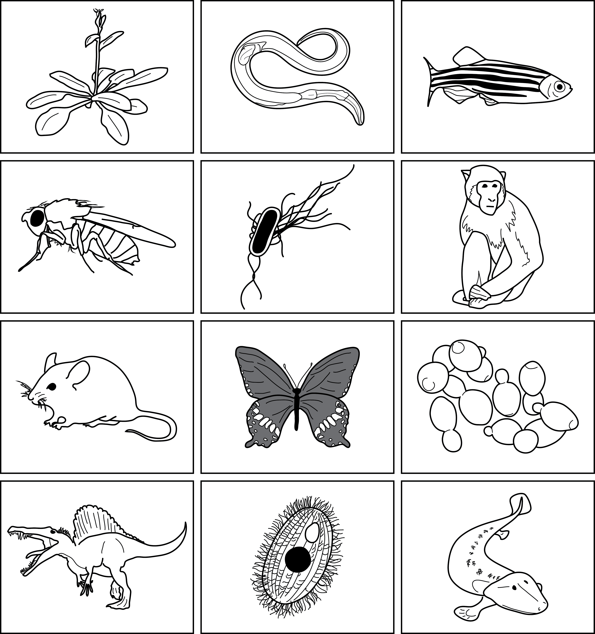

***September 5 – 11, 2015***

***Marine Biological Laboratories***

***Woods Hole, MA***